

**DREAM TRAVEL AGENCY**

**NORTHERN TRAILS**

**COURSE: AICT-LAB (Web Development)**

**INSTRUCTORS: Ma’am Ramsha Khalid & Sir Mudassir**

|  |  |
| --- | --- |
| **GROUP MEMBERS** | **ROLL NO.** |
| Meerab Usman | 2025-CS-275 |
| Sana Humayun | 2025-CS-257 |
| Zaineb Asif | 2025-CS-244 |
| Arisha Mohsin | 2025-CS-290 |
| Noor Fatima | 2025-CS-245 |

**DATE:**

**EXECUTIVE SUMMARY**

**Dream Travels** is a premier travel consultancy and a professionally architected front-end web platform dedicated to showcasing the natural wonders of Pakistan. Specializing in the majestic **Northern Trails**, we provide curated, hassle-free experiences across **Naran, Hunza, and Azad Kashmir**. Our business model is centered on **transparency and personal responsibility**, ensuring that every traveler’s investment of time and safety is handled with ethical pricing and precision planning. Developed as a high-performance digital solution, the platform utilizes **clean HTML5/CSS3 architecture** and **responsive design principles** to deliver an intuitive user interface. The project features a structured content flow across nine dedicated modules including specialized Travel Packages, an interactive Gallery, and a multi-step Contact portal enhanced by interactive UI elements, optimized image layouts, and integrated Google Maps API. Dream Travels isn't just a booking tool; it is a scalable, production-ready digital environment designed to bridge the gap between complex travel logistics and a "**dreamy**" user experience.

**PROJECT OBJECTIVES**

The primary goal was to build a specialized digital gateway for **Dream Travels** that converts complex travel logistics into a user-friendly visual experience. The specific objectives were:

* **Professional Identity:** To design a cohesive, luxury-themed travel agency brand using advanced CSS typography and layout principles.
* **Visual Storytelling:** To use a dedicated Gallery module and Hero Video background to immediately build an emotional connection with travelers interested in Northern Pakistan.
* **Transparency and Trust:** To eliminate the "hidden cost" problem in the tourism industry by providing clear Package Pricing (e.g., PKR 34k–40k) and day-by-day itineraries directly on the destination pages.
* **Lead Optimization:** To design a multi-step contact system that guides the user through the inquiry process without overwhelming them, increasing the chance of a successful booking request.
* **Support Self-Service:** To reduce manual customer support work by implementing a detailed FAQ section that addresses safety, packing, and weather concerns before the user even asks.

**PROJECT SCOPE**

The scope of this project involved the front-end architecture and UI design of a web portal. Key points include:

* **Integrated Destination Framework:** Development of specialized landing pages for Naran, Hunza, and Azad Kashmir, each featuring a standardized “Price Cards”, “Gallery Grid” and “Tour Route” map.
* **Responsive Multi-Page Navigation:** A consistent, SEO-friendly header and footer across all 9 modules (Home, About, Services, Gallery, FAQ, Contact, and the 3 Destination pages).
* **Interactive UI Components:** The scope includes the implementation of following to simulate a real-world business interaction.
  + A CSS-based Light-box Gallery for high-definition image viewing.
  + Accordion-style FAQs for clean information density.
  + Hover-responsive Service Cards to highlight different travel packages.
* **Geographic Integration:** Embedding Google Maps to provide users with real-world spatial awareness of their travel routes.
* **Premium Branding:** Implementing a “Luxury-Aesthetic” using the Playfair Displaytypography and a clean, high-contrast color palette suitable for a professional travel agency.
* **Platform Boundaries:** The system is built as a front-end only solution, intentionally excluding backend processing or database management to focus on client-side performance and styling.

**SITE STRUCTURES AND NAVIGATION**

The **Dream Travel Agency** platform is built on a **modular, multi-page architecture** designed to guide users seamlessly from **inspiration** (Discovery Layer) **to information** (Trust Layer) and **action** (Conversion Layer):

**INSPIRATION → INFORMATION → ACTION**

* **Inspiration:** Home and Gallery pages to engage and motivate users.
* **Information:** Services, About and FAQ pages provide clarity and build trust.
* **Action:** Contact page captures leads and converts interest into bookings.

**INFORMATION ARCHITECTURE**

The Dream Travels website follows a structured and intuitive navigation layout that allows users to move smoothly between pages. Content is logically organized to ensure clarity, ease of access, and a consistent browsing experience across the entire site.

**TECHNICAL ARCHITECTURE**

We have structured our project into 9 modular HTML files. In this table, We've mapped each file name to its specific business role as an 'Inquiry Engine' to show how the code supports the travel agency's goals.

|  |  |  |  |
| --- | --- | --- | --- |
| File Name | User Interface Label | Technical Role | Key Lists |
| index.html | **Home** | Primary Entry Hub | Hero Video, 4 Core Value Propositions. |
| about.html | **About Us** | Company Profile | 4-Step Workflow: Analysis, Design, Confirmation, Assistance. |
| service.html | **Services** | Catalog Layer | Grid of 3 Package Cards; Navigation Router to Destinations. |
| naran.html | **Naran** | Product Details | Price: PKR 34,000.  Highlights: Saif-ul-Malook, Lalazar. |
| hunza.html | **Hunza** | Product Details | Price: PKR 37,000.  Highlights: Baltit Fort, Attabad Lake. |
| kashmir.html | **Kashmir** | Product Details | Price: PKR 40,000.  Highlights: Neelum Valley, Arang Kel. |
| gallery.html | **Gallery** | Visual Portfolio | CSS Grid Layout; Hover-active Image Cards; HD Assets. |
| faq.html | **FAQs** | Support Center | Safety Protocols, Packing Lists, Weather Advisories. |
| contact.html | **Contact** | Lead Capture | 3-Step Funnel: Identity → Trip Parameters → Customization. |

**Table 1.1: Functional Decomposition of Web Modules**

**Detailed Module Specifications**

In this section, the technical implementation of each page is detailed, quoting the exact data points and visual assets used in the final build.

* **Home Module (index.html)**

The Home page serves as the high-impact entry point for the “Inspiration” phase of the user journey.

**Technical Highlight:** Uses a full-screen background video with a CSS-positioned brand overlay.

**Core Value Drivers:**

* Expert local guides with years of experience.
* Customized itineraries for adventure seekers.
* Eco-friendly and responsible tourism.
* 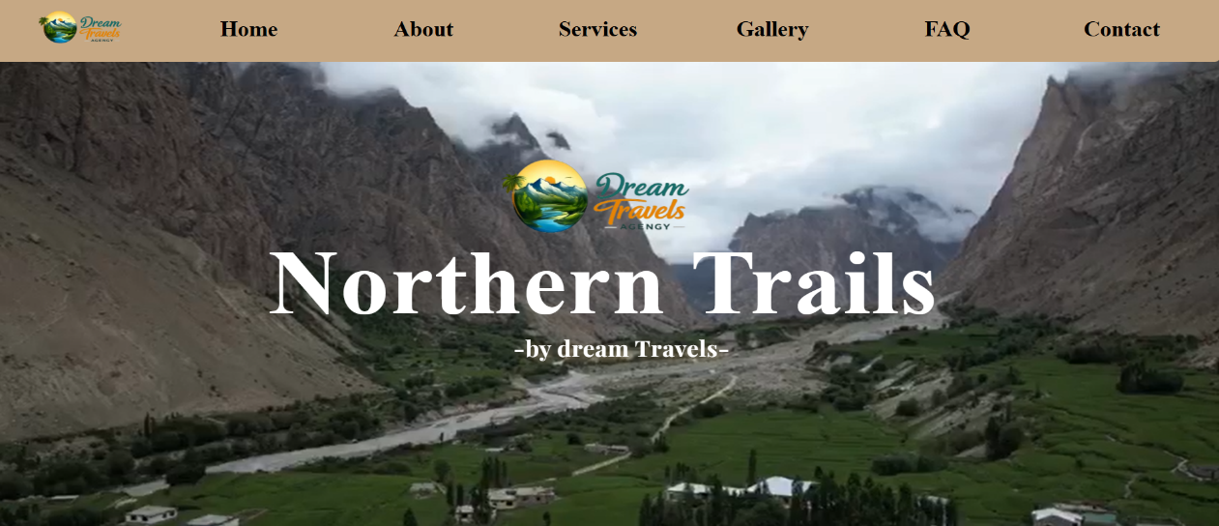24/7 support and hassle-free bookings.
* **About Module (about.html)**

**The 4-Step Operational Framework :**

* + **Requirement Analysis:** Detailed consultation to understand traveler preferences.
  + **Practical Design:** Crafting realistic and optimized travel routes.
  + **Transparent Confirmation:** Finalizing bookings with no hidden costs.
  + **In-Trip Assistance:** Providing 24/7 on-ground support during the journey.

**Core Brand Pillars:**

* **Integrity:** Honest pricing and verified hotel partners.
* **Safety:** Certified drivers and secure travel corridors.
* 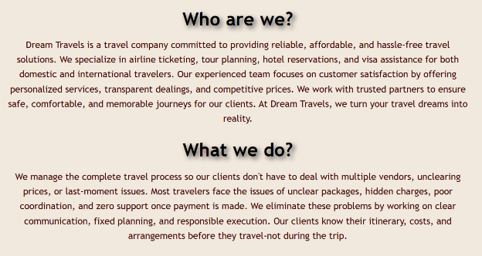**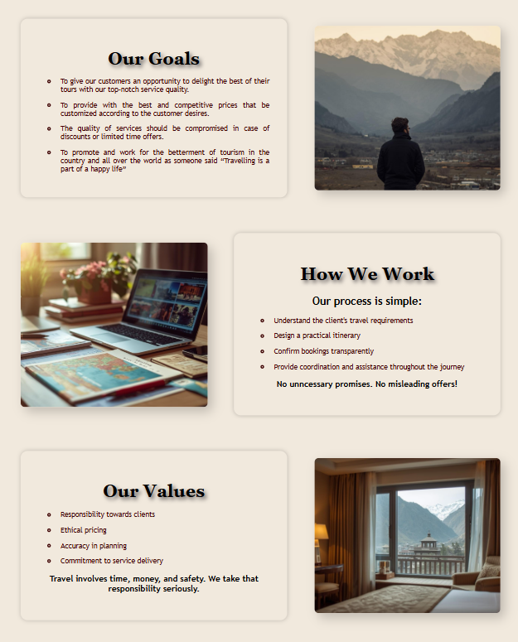Experience:** Over a decade of expertise in Northern Pakistan tourism.
* **Service Module (service.html)**

The Services module acts as the central directory for the agency’s travel products. Technically, this page functions as a “Central Navigation Hub”, allowing users to filter their interests before moving into the deep-detail product pages.

**Technical Highlight:** Employs a Modular Grid System where each service card acts as a gateway to the destination-specific HTML files.

**Service Inclusion Suite:**

* **Transport:** Dedicated vehicles for the full 5-day itinerary.
* **Hotel Accommodation:** Verified stays with standard/executive options.
* **Guided Tours:** Expert-led walks and historical briefings.
* **Meal Plan:** Daily Breakfast and Dinner included.

**Direct Destination Access:**

* **Naran Gateway:** Links to 5-day itinerary at PKR 34,000.
* **Hunza Gateway:** Links to 5-day itinerary at PKR 37,000.
* **Kashmir Gateway:** Links to 5-day itinerary at PKR 40,000.
* **Gallery Module (gallery.html)**

Designed for "Social Proof," this module utilizes a CSS Grid layout to manage high-definition visual assets.

**Technical Implementation:** Features hover-active cards that provide a seamless transition effect, enhancing user engagement without the need for JavaScript.

**Content:** Organized into Top Destinations, Cultural Heritage, Food and Cuisines and Adventure activity categories.

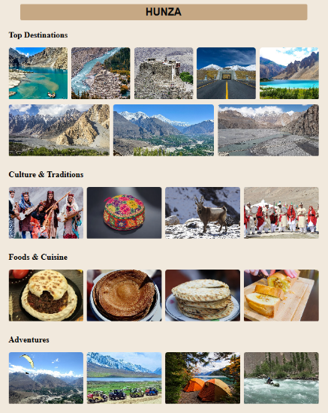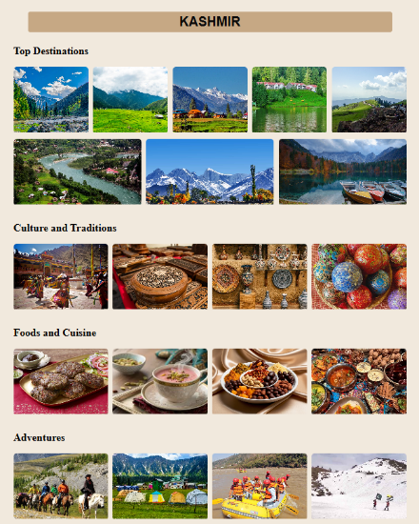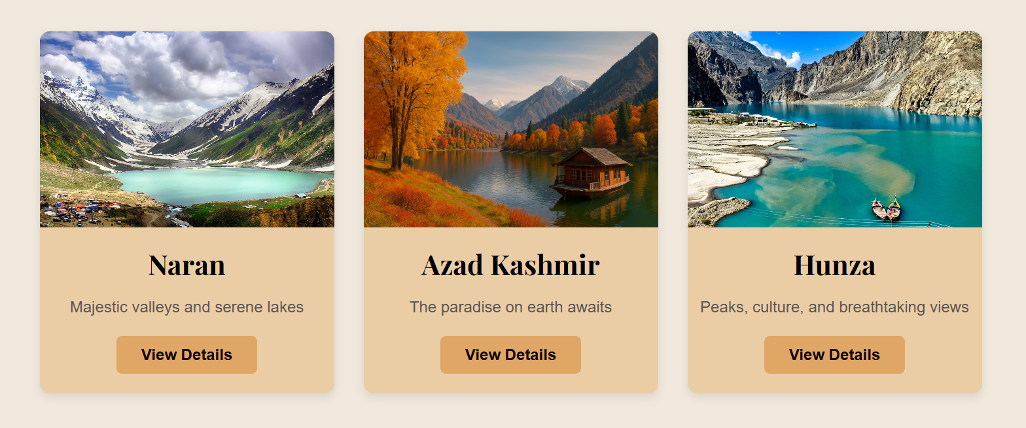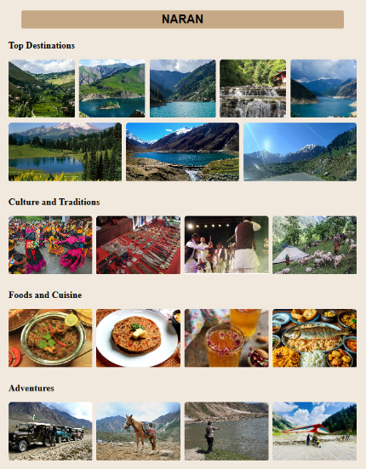

#### **Contact Module (contact.html)**

The "Action" phase of the site is powered by a 3-step logical funnel designed to gather travel request information.

**Funnel Logic:**

* **Identity:** Name, Email, and Phone Number.
* **Parameters:** Destination Selection, Group Size, and Date.
* **Customization:** Specific traveler requirements and special requests.

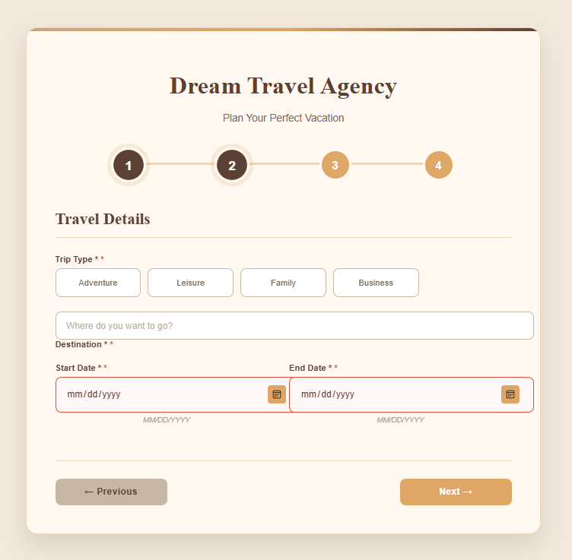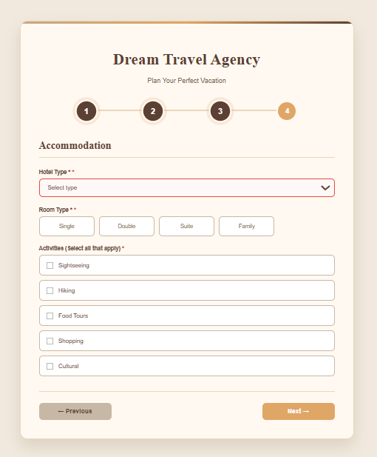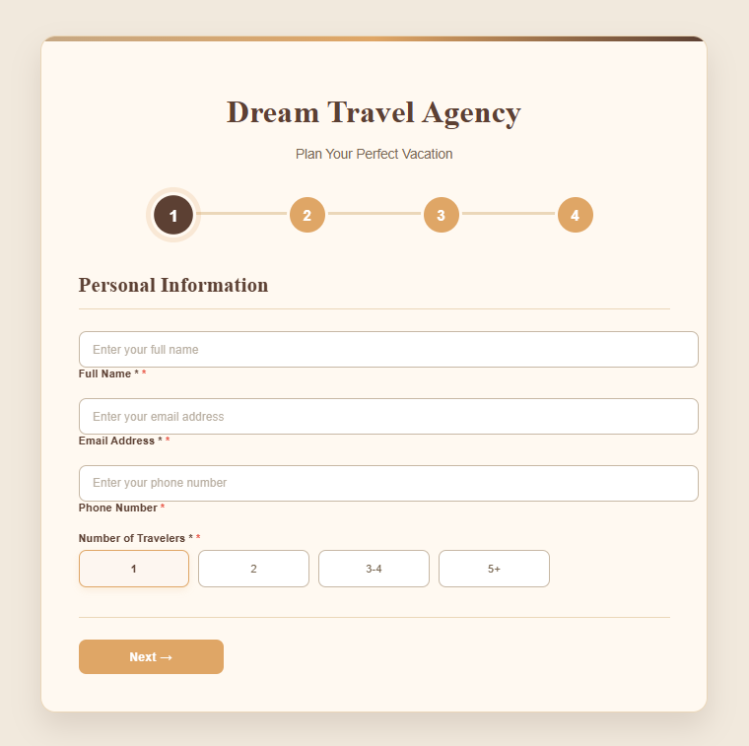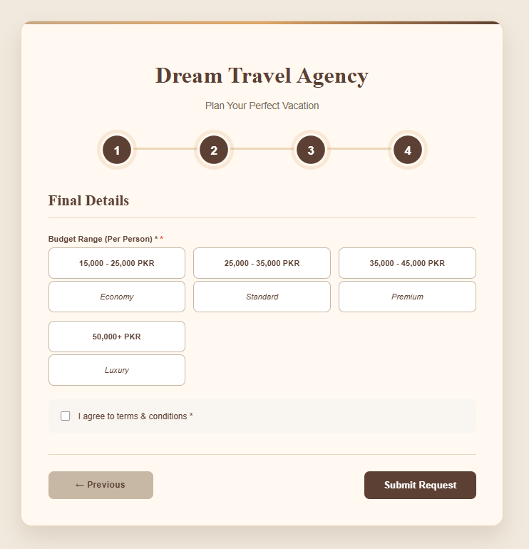

* **FAQ Module (faq.html)**

The FAQ page is a "Trust-Building" interface that addresses user concerns before they reach the booking stage.

**Key Lists Quoted:**

* **Safety:** Detailed security protocols for family travelers.
* **Packing:** Requirement for warm clothing and trekking boots.
* **Weather:** Seasonal window recommendations.

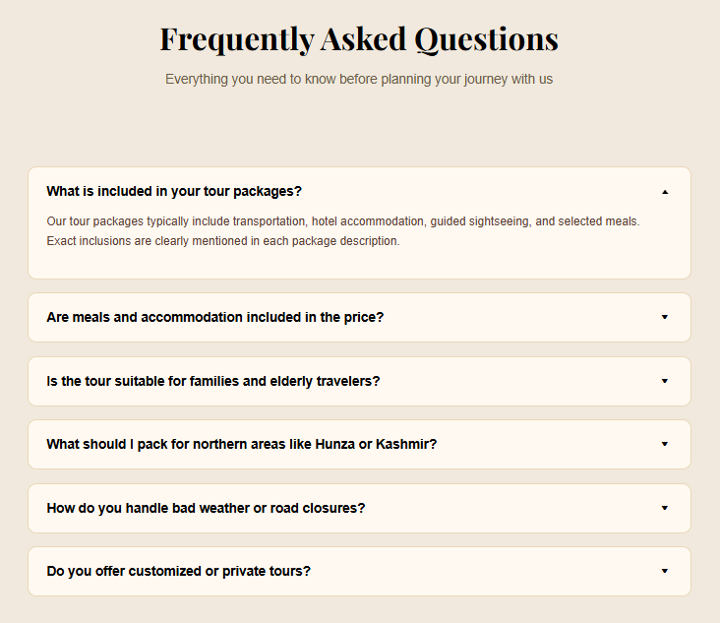

* **Destination Modules (naran.html, hunza.html, kashmir.html)**

These pages provide the "Information" layer, using standardized pricing and itinerary lists to maintain consistency in pricing and itinerary information.

**Naran Valley:**

* **Quoted Price:** PKR 34,000 / Person.
* **Highlights:** Lake Saif-ul-Malook, Lalazar Meadows, and Kiwai Waterfall.

**Hunza Valley:**

* **Quoted Price:** PKR 37,000 / Person.
* **Highlights:** Baltit Fort, Altit Fort, and Attabad Lake.

**Azad Kashmir:**

* **Quoted Price:** PKR 40,000 / Person.
* **Highlights:** Neelum Valley, Arang Kel, and Ratti Gali Lake.

|  |  |  |
| --- | --- | --- |
| **NARAN** | **AZAD-KASHMIR** | **HUNZA** |
|  |  |  |

* **The Purpose of Navigation**

The navigation is designed as a "Conversion Path." It is not just a list of links; it is a guided journey:

* **Top-Level Navigation:** Provides immediate access to the high-level categories (Home, About, Services, Gallery, FAQ).
* **Internal Call-to-Actions:** Within the pages, "Book Now" buttons act as Secondary Navigation, routing the user directly to the contact.html inquiry engine.
* **Footer Navigation:** Acts as a "Safety Net," providing links to the Support and Social sections so the user never reaches a "dead end".

**Design Philosophy and Visual Identity**

The visual identity of Dream Travels is engineered to balance "Earth-Tone" aesthetics with high-performance usability. The design reflects the natural landscapes of Northern Pakistan using a warm, professional palette.

**Typography and Font Selection**

* **Primary Display Font:** Used for high-impact headings like "Services" and "Kashmir" to provide a sophisticated, editorial feel.
* **Secondary Functional Font:** The primary body font used across all modules. Chosen for its universal compatibility and clean readability at small sizes (14px–18px).
* **Technical Implementation:** Fonts are imported via the Google Fonts API, with text-shadows applied to hero text to ensure legibility against background imagery.

**Color Palette and Psychological Impact**

* **Background Foundation:** A warm, off-white "sand" color used as the site-wide background to reduce eye strain compared to pure white.
* **Navigation & Accents:** Earthy tan and bronze tones used for the top navigation bar and itinerary timelines, reflecting mountain and autumn landscapes.
* **Call-to-Action Color:** A muted "Sunset Orange" used for "Book Now" buttons. It provides high contrast against the background without appearing aggressive.
* **Contrast and Footer:** A deep "Midnight Blue" used for footers and checkmark icons, providing a strong visual anchor at the end of each page.

**Layout and Structural Decisions**

* **The Grid System:** The Gallery and Destination modules utilize display: grid with repeat allowing the layout to automatically rearrange based on the user's screen width.
* **Interactive Cards:** Service and Gallery items utilize transition: transform 0.3s and scale(1.05) on hover. This provides immediate visual feedback, making the site feel "alive" and interactive.
* **Sticky Navigation:** The .top-nav uses position: fixed, ensuring the user always has access to the menu, regardless of how far they scroll down an itinerary.

**Asset Acquisition and Optimization**

This section details the media, data, and technical resources used to build the Dream Travels platform, focusing on high-definition visual assets and verified travel information.

* **Visual Sourcing:** All imagery was curated from professional-grade, royalty-free repositories. Each asset was selected to match the specific "Wanderlust" aesthetic of Northern Pakistan.
* **Image Processing:** To ensure a clean UI, subjects were isolated using advancedmasking techniques, removing background noise to create focused icons and transparent overlays.
* **Motion Graphics:** The homepage features a custom-processed hero video (vv.mp4). This asset was compressed and transcoded to ensure a balance between high visual fidelity and fast initial page load.
* **Fonts:** Sourced via Google Fonts API. We utilized Playfair Display for a high-end editorial feel in headings and Arial/Sans-Serif for maximum readability in body text and forms.
* **Performance Tuning:** All static images were converted to optimized web formats, maintaining a target file size of under 200KB to ensure a high Core Web Vitals score.

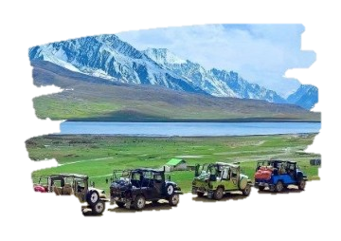



**Let’s**

**Explore the Extraordinary**

**Let's explore top destinations with our travel agency.**



**Contact Us For**

**More Info**

 **0302-0000003**

 dreamtravels@gmail.com

**Our Company is committed to providing affordable and hassle-free travel solutions. We specialize in tour planning, hotel reservations for both domestic and international travelers. Our experienced team focuses on customer satisfaction by offering personalized services, transparent dealings and competitive prices.**

**At Dream Travels, we turn your dreams into reality.**

**ABOUT US**

“A journey of a thousand miles begins with yourself."

**NORTHERN TRAILS**

### 

### 

### 

### 

HUNZA

### **5-Day Itinerary:**

### 01 - Arrival in Muzaffarabad

### 02 – Neelum Valley Excursion

### 03 – Ratti Gali Lake & Surroundings

### 04 – Shounter Valley & Arang Kel

### 05 – Return to Islamabad

### **5-Day Itinerary:**

### **01 -** Departure & Arrival in Naran

### **02 -**  Saif-ul-Malook Lake Excursion

### **03 -** Lalazar & Upper Kaghan Valley

### **04 -** Babusar Top & Surrounding Valleys

### **05 -** Return Journey

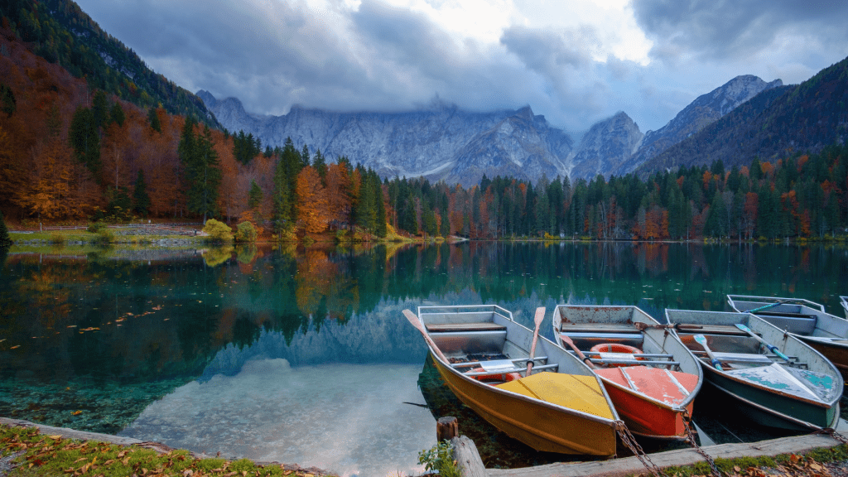

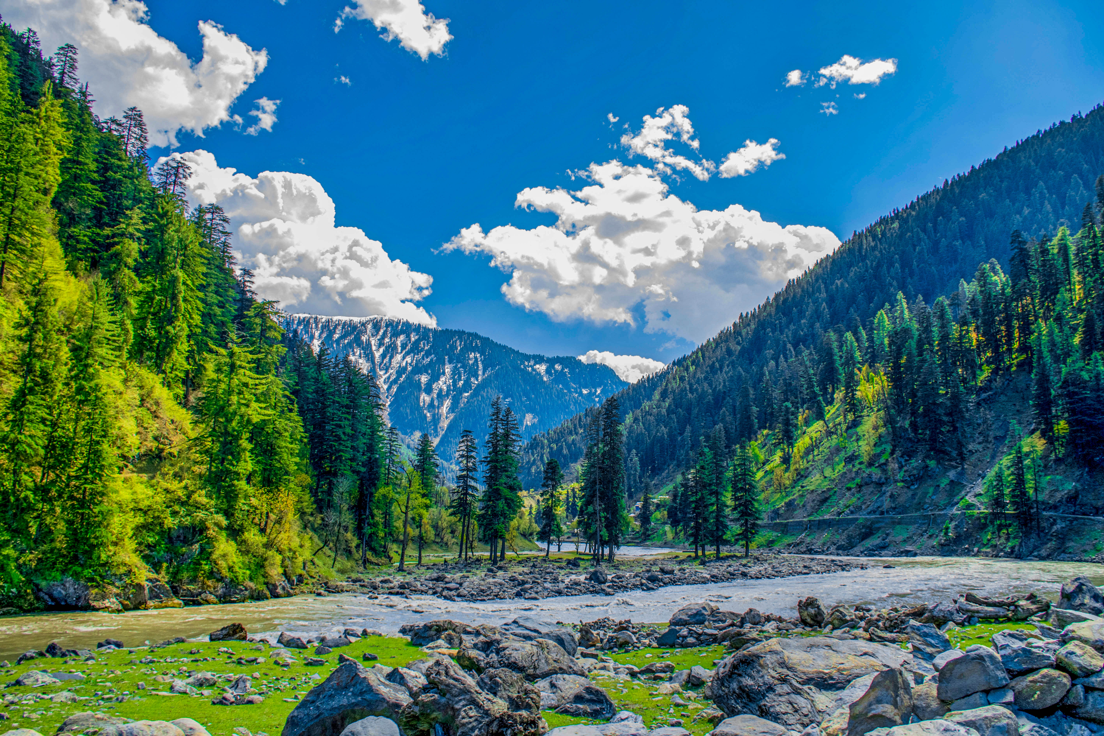

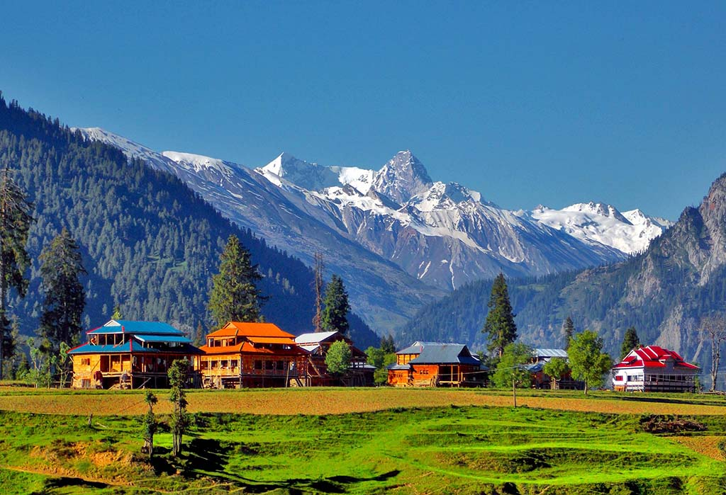

KASHMIR

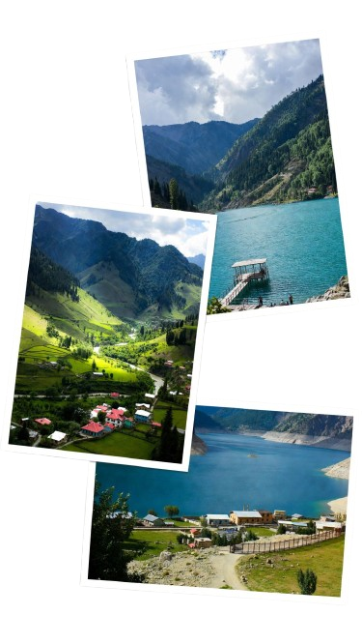

NARAN

### **5-Day Itinerary:**

### 01 - Arrival in Gilgit

### 02 - Hunza Valley Exploration

### 03 - Passu & Khunjerab Pass

### 04 - Hopper Glacier & Attabad Lake

### 05 - Return Journey

**Deployment and Execution Guide**

This module provides the technical protocol for initializing, testing, and publishing the "Dream Travels" platform.

**Environment and System Requirements**

To ensure the high-definition media and CSS Grid layouts render correctly, the following environment is required:

* **Operating System:** Windows 10/11, mac-OS, or Linux.
* **Browser Compatibility:** Chromium-based browsers (Chrome, Edge, Brave) or Firefox (latest version).
* **Recommended IDE:** VS Code (for local source code modifications).

**Local Execution (Step-by-Step)**

* **Repository Extraction:** Download and unzip the project folder.
* **File Path Validation:** Ensure that index.html is at the root level. Do not rename the images folders, as the HTML uses **relative pathing** to link these assets.
* **Launching the Site:**

**Method A:** Right-click index.html and select **"Open with Google Chrome."**

**Method B:** Open the folder in VS Code and launch using the **Live Server** extension to simulate a real-time web hosting environment.

* **Verification:** Upon launch, verify that the vv.mp4 video background plays automatically (muted) and that the navigation bar remains "sticky" during scroll.

**Web Publishing (Live Deployment)**

To make the website accessible to customers globally, the following deployment pipeline is recommended:

* **Version Control:** Upload the project files to a **GitHub** repository. This acts as a backup and a version history for the code.
* **Hosting Platform:** Link the GitHub repository to **GitHub Pages**. These platforms are optimized for "Static Sites" (HTML/CSS).
* **Domain Mapping:** Once published, the site will receive a unique URL. This can be mapped to a custom .pk or .com domain.
* **SSL Integration:** GitHub Pages provide automatic **HTTPS encryption**, ensuring that the "Contact Us" form data is transmitted securely.

**Live Site URL:** **“**[**https://sanahumayun147-h.github.io/Dream-Travels-Project/**](https://sanahumayun147-h.github.io/Dream-Travels-Project/)**”**

**Project Reflection & Future Enhancements**

**Key Learning Outcomes**

Developing the "Dream Travels" platform provided significant insights into modern web development and brand engineering:

* **Asset Management:** Mastered the integration of high-definition video backgrounds (vv.mp4) while maintaining smooth UI performance.
* **Grid Architecture:** Gained proficiency in CSS Grid and Flexbox to build a responsive 9-page layout that stays consistent across all devices.
* **channel Branding:** Learned to synchronize digital assets (HTML/CSS) with physical collateral (Brochure) using a unified color palette.
* **­Information Hierarchy:** Developed a deep understanding of how to structure complex travel itineraries so they are easy for users to scan and understand.
* **Responsive Design Logic:** Learned how to use Media Queries to ensure the navigation and gallery remain functional on both desktop and mobile screens.
* **User Path Optimization:** Discovered how to create a "Conversion Funnel" that leads a user naturally from a home page video to a final contact form.

|  |  |
| --- | --- |
| Challenges | Solutions |
| The background video (vv.mp4) was slowing down the initial page load. | Optimized the **video file size** and used the muted, autoplay, and loop attributes within the HTML5 <video> tag for seamless rendering. |
| Managing links across 9 different pages made it easy for users to get lost. | Developed a **Global Navigation Matrix** with a "sticky" header, ensuring the menu is always accessible regardless of scroll position. |
| Destination photos (Naran, Hunza, Kashmir) had different sizes and styles. | Applied a uniform **CSS Class** with a 10px border-radius and fixed aspect ratios to create a cohesive "Gallery" look. |
| The 3-column package grid broke when viewed on smaller mobile screens. | Implemented **CSS Media Queries** to transition the grid from 3 columns to a single-column stack on mobile devices. |
| Matching the MS Word brochure colors exactly to the website's CSS codes. | Used specific **Hex Codes** in both the CSS file and the Word Design settings for 100% brand alignment. |
| It was hard to get the text and icons to stay in the center of the boxes. | Used **Flexbox commands** (center) to make sure everything stayed perfectly in the middle. |
| Some cards were tall and some were short because of the text inside.I set a Minimum Height for all boxes so they look equal and neat in a row. | Set a **Minimum Height** for all boxes so they look equal and neat in a row. |

**Challenges and Solutions**

**Table 1.2:** Challenges faced and their Solutions

**Improvements**

While the current version of the Dream Travels website is a fully functional and stable platform, it serves as a foundational project that is designed to be scaled and enhanced with more advanced features in the future. To further improve the user experience and technical depth, the following updates are planned:

* **Interactive Google Maps:** Add a live map on each destination page so users can see the exact route from Islamabad to Naran or Hunza.
* **Live Booking Form:** Improve the contact form so it sends an instant email notification to the agency whenever a customer submits their details.
* **Multi-Language Support:** Add a "Language" button to switch the website text between **English and Urdu**, making it easier for local travelers to use.
* **Chat-bot Integration:** Add a "WhatsApp Chat" button that floats on the corner of the screen so customers can ask questions and get replies immediately.
* **Customer Reviews Section:** Add a section where travelers can upload their own photos and leave star ratings for the trips they took.
* **Dark Mode Toggle:** Add a button that allows users to switch between the "Sand" theme and a "Dark Mode" theme for better viewing at night.
* **Weather Widget:** Include a small live update showing the current temperature and snowfall status for the Northern areas.

**Conclusion**

The **"Dream Travels"** project successfully demonstrates the development of a modern, responsive travel portal and its accompanying marketing materials. By building a **website** and **brochure**, we have showcased the ability to maintain a consistent brand identity across both digital and physical platforms.

**The world is a book, and those who do not travel read only a page.**

**(Augustine)**

Technically, this project was a valuable exercise in mastering **HTML5 and CSS3**, particularly in solving real-world challenges like **Flexbox layouts, responsive design, and media optimization**. The result is a user-centric platform that is not only visually appealing but also strategically structured to drive customer engagement.

Moving forward, the architecture of this site is designed to be **scalable**, allowing for future integrations. Overall, this project has provided us with a solid foundation in web development and professional documentation, preparing us for more complex software engineering challenges in the future.

**THANK YOU!**